
CHURCHLANDS SENIOR HIGH SCHOOL
MATHEMATICS SPECIALIST 3, 4 TEST ONE 2017
Calculator Section
Chapters 1, 2,

Name________________________________ Time: 40 minutes
Total: 36 marks

1. [5 marks:3,2]
a) State the complex relationship represented by the shaded region.

b) Sketch the following regions in the complex plane.
$\left\{z: -\frac{π}{2}<arg⁡(z)≤\frac{3π}{4}\right\}$

2. [3 marks]
If $z=\sqrt{2}cis(\frac{-4π}{5})$, find $w=z^{9}$ expressing your answer in exact polar form.

3. [6 marks]
Find the 4 fourth roots of -4 in the form $z=rcisθ$ where $r≥0$ and $-π<θ≤π.$You need to show evidence of having used De Moivre’s theorem to gain full marks.

4.[10 marks: 2,5,3]

a) State the exact value of ${(1-\sqrt{3}i)}^{4}$ in Cartesian form.

b) Hence, determine exact values for all the roots of $z^{4}=-648+648\sqrt{3}i$

c) Sketch all the solutions from your answer above on the Argand diagram below.

5.[3 marks]
On the argand diagram below, the 12 points p₁, p₂, p₃, …p₁₂ are evenly spaced around the circle of radius 3.
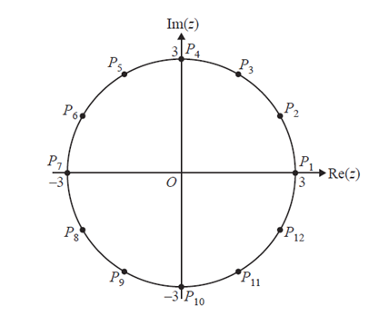
Find the points which represent complex numbers such that $z^{3}=-27i$

6.[3marks]

Consider $f\left(z\right)=z^{3}+9z^{2}+28z+20,z∈C(complex numbers)$.
Given $f\left(-1\right)=0$, factorize $f(z)$ over $C$.

7. [6marks:3,3]
a) Sketch in the complex plane the region defined by $1≤|z-8-6i|≤4$.

b) Determine in polar form $rcisθ$, $-π<θ≤π$, the complex number $z$ that satisfies
$\left|z-8-6i\right|=4$ and has the minimum argument.

